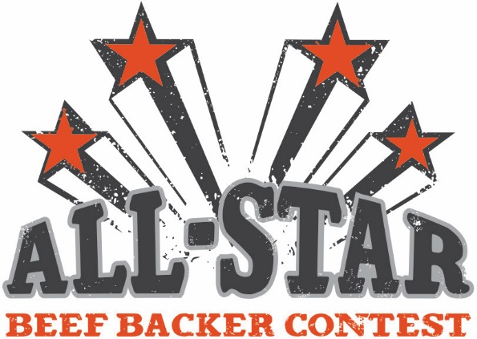
Evaluation Form
County: ________________________________ Date of promotion: ______________________________________
Contact person
Name: __________________________________________ Phone Number: ___________________________________
Address: _____________________________________________________________________________________________
Please check the following items that you completed during your promotion:
- Held event at local grocery store
- Advertised in local publication (must send copy of ad for credit)
- Used beef promotional items provided by Tennessee beef Industry Council
- Sent pictures of event with evaluation form
- Completed and returned promotion evaluation form
- Held an enter-to-win giveaway
- Make a 1-2 Minute Video recapping the event

Please provide any additional information that was not covered for review.
(May use additional pages if needed)
_____________________________________________________________________________________________________________________________________________________________________________________________________________________________________________________________________________________________________________________________________________________________________________________________________________________________________________________________________________________________________________________________________________________________________________________________________________________________________________________
_________________________________________________________________________________________________________
__________________________________________________________________________________________________________________________________________________________________________________________________________________
All evaluation forms, videos, pictures and ads must be turned in by August 13th, 2018 for entry.
Please send to: Tennessee Beef Industry Council:
530 A Brandies Circle, Murfreesboro, TN 37128. Questions? Call 615-896-5811.

