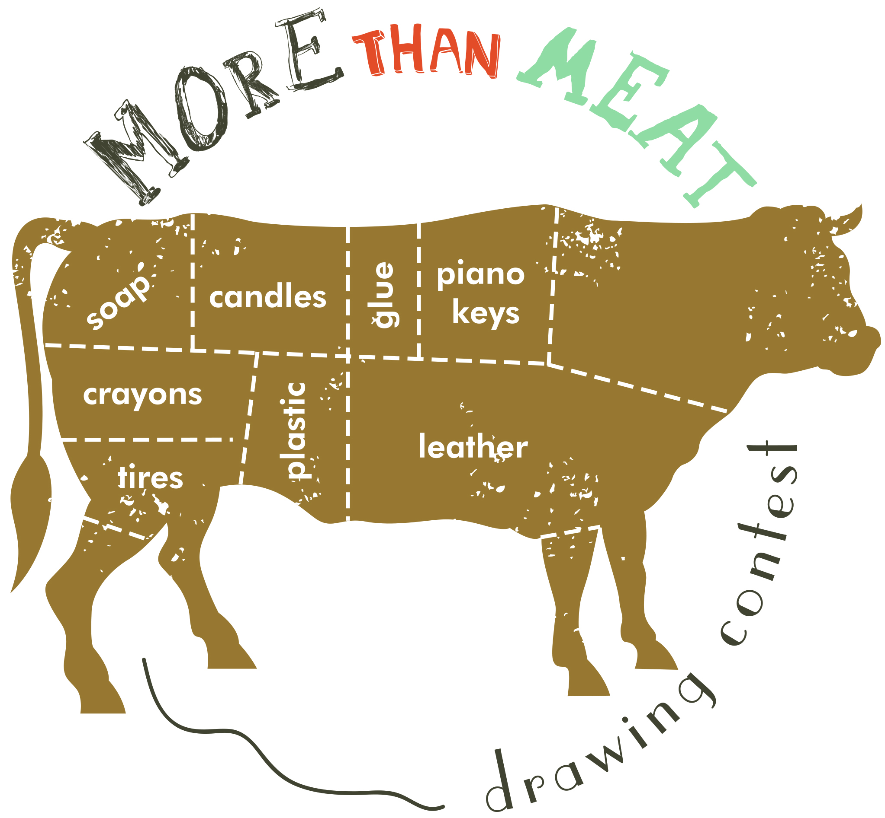
We all know that cattle provides us with delicious beef to eat, but the parts of the animal that are not used for food are used to make a wide range of other products, these products are called by-products. Because of these by-products, we are able to use 99% of every animal. Draw a picture that demonstrates how cattle help the environment and/or the by-products that come from cattle.
All entries must be on cardstock, 8.5 x 11
Name, Grade, County, Address, and Phone Number need to be listed on the back of the entry,
top left corner.
Winners will be judged based on creativity and factual information. There will be no county winners.
One 1st place winner will be selected in each age division:
Division 1: Grade K-3 (Clover Bud)
Division 2: Grade 4 (Explorer)
Division 3: Grade 5 (Junior)
Division 4: Grade 6-8 (Junior High)
(Grade Level as of January 1st, 2020)
The winner of each division will be awarded $100.00. Winners will be placed on the Tennessee Beef Industry Council’s social media outlets and published in agriculture publications throughout the state. Once entries are submitted they become property of the Tennessee Beef Industry Council.
Submit Entries To:
Tennessee Beef Industry Council
Attn: Janna Sullivan
530 A Brandies Circle
Murfreesboro, TN 37128
All entries must be postmarked by July 1st, 2020
For questions contact:
Janna Sullivan, Tennessee Beef Industry Council at
615-896-5811 or jsullivan@tnbeef.org

